<page_start no = 1>
<sol_start id=1>
1. Hypermetropia
<sol_end>

<sol_start id=2>
2. Repulsion
<sol_end>

<sol_start id=3>
3. Virtual and erect
<sol_end>

<sol_start id=4>
4. below the apparent image of the fish
<sol_end>

<sol_start id=5>
5. Given P = +1.5 D
f = 66.7 cm
The lens are converging, thus they are convex lens.
<sol_end>

<sol_start id=6>
6. Current flowing (I) = 5 Amp.
Time (t) = 30 mins
Q = It
Q = 5×1800
Q = 9000 C
coulombs
Ans. 9×10³ coulombs of charges flows through the circuit.
<sol_end>
<page_end>

<page_start no = 2>
<sol_start id=7>
7.
 | Circuit components | Symbol
(1) | Electric cell | 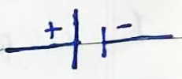
(2) | Switch (in off position) | 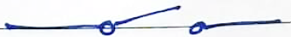
(3) | Switch (in on position)
(4) | Electric bulb | 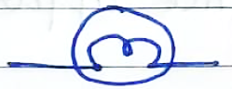
(5) | Battery | 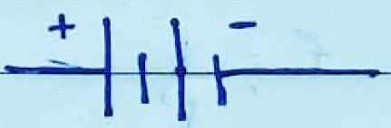
<sol_end>

<sol_start id=8>
8. f = +12 cm
h = 5 cm
u = –20 cm
v = 30 cm
Image is formed 30 cm behind the convex lens and the image is real and inverted.
<sol_end>
<page_end>

<page_start no = 3>
<sol_start id=9>
9. The potential difference between the two ends of the conductor (V) = 10V – 5V = 5V
potential difference = 5V
(W) work done = 5 J
(Q) charge = ?
Q = 1 colomb
<sol_end>

<sol_start id=10>
<sub_id = 1>
10. (a) Pole : The centre of a spherical mirror is called the pole. It lies in front of a concave mirror.
<sub_id end>
<sub_id = 2>
(b) Radius of curvature : Radius of curvature of a spherical mirror is the radius of the hollow sphere of glass of which the mirror is a part. In case of a concave mirror the radius of curvature lies front of the mirror.
<sub_id end>
<sub_id = 3>
(c) Principal axis the straight line passing through the centre of curvature and pole of a spherical mirror is called its principal axis. The principal focus lies in front of a concave mirror
<sub_id end>
<sub_id = 4>
(d) Principal focus : It is the point of the principal axis at which the rays parallel to the principal axis meet after reflection. It is represented by (F). The principal focus lies in front of the concave mirror.
<sub_id end>
<sol_end>
<page_end>

<page_start no = 4>
<sol_start id=11>
<sub_id = 1>
11. The object distance should be less than the focal length for the formation of an erect image on a concave mirror. Hence, the range of distance of object from the mirror should be less than 20 cm i.e. from 0 to 20 cm in front of the mirror from the pole. The nature of image so formed will be virtual and erect. The size of the image will be larger than the object.
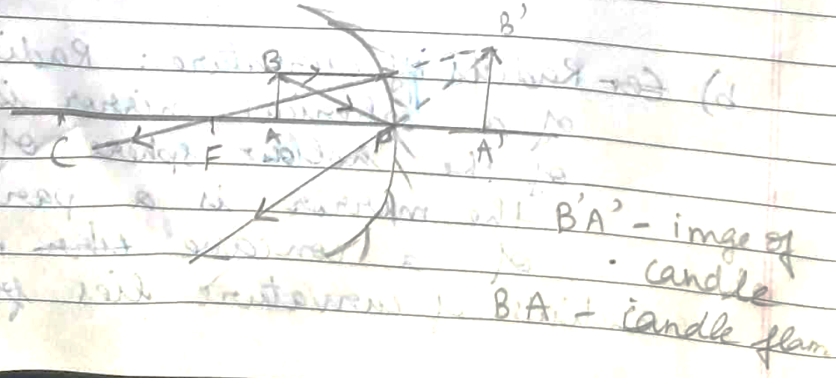
- Since blue colour has a shorter wavelength and red colour has a longer wavelength, the red colour is able to reach our eyes after the atmospheric scattering of light whereas, the blue colour is scattered all over. Therefore, the sun appears reddish during early in the morning.
<sub_id end>
<sub_id = 2>
- Power of accommodation of eye is the ability of the eye lens to focus near and far objects clearly on the retina by adjusting its focal length. Poer of accommodation of the eye is limited. It implies the focal length of the eye lens cannot be reduced beyond certain minimum limit.
<sub_id end>
<sub_id = 3>
- Least distance of distinct vision for a normal human being is 25 cm.
<sub_id end>
<sol_end>
<page_end>

